**Experiment No: 3**

**Aim:** Familiarization of Linux commands.

**CO2:** Perform System Administration tasks.

**Procedure:**

1. **pwd :** pwd stands for Print Working Directory. It prints the path of the working directory, starting from the root. All directories are separated by a / (slash). The root directory is represented by the first /, and the last directory named is your current directory.

**$ pwd**

**Output:**



1. **ls :** used to list files and directories. The contents of your current working directory, which is just a technical way of stating the directory that your terminal is presently in, will be listed if you run the "ls" command without any further options.

**$ ls**

**Output:**



1. ls -R : list all files recursively, descending down the directory tree from the given path.

**$ ls -R**

**Output:**

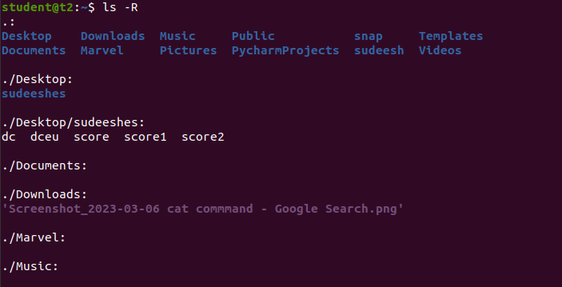

1. ls -l : list the files in long format i.e. with an index number, owner name, group name, size, and permissions.

**$ ls -l**

**Output:**

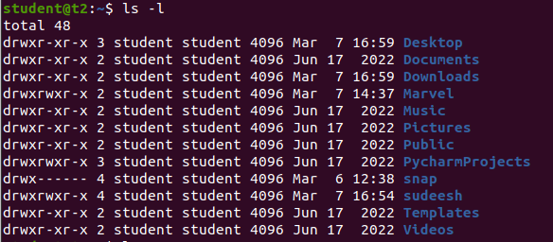

1. ls -a : list all files including hidden files. These are files that start with “.”.

**$ ls -a**

**Output:**

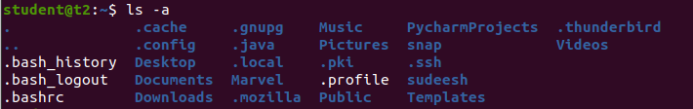

1. ls -al : **list all the files including hidden files in the current directory.**

**$ls -al**

**Output:**

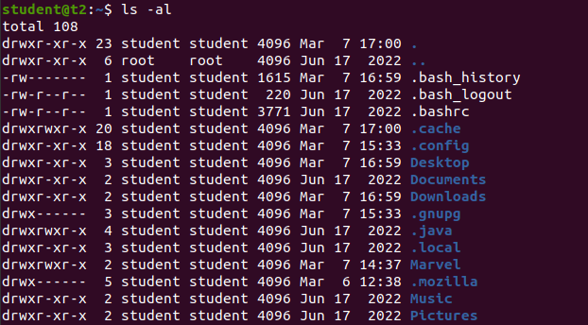

1. ls -t : sort the list by time of modification, with the newest at the top.

**$ ls -t**

**Output:**

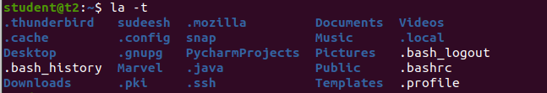

1. ls -r : will reverse the natural sorting order.

$ ls -r

**Output:**

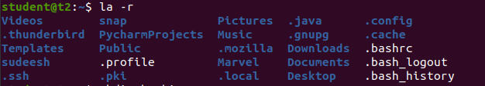

1. mkdir : used to make a directory.

**$ mkdir <directory name>**

**Output:**

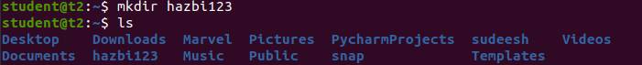

1. cd : to navigate through the directory.

**$ cd <directory name>**

**Output:**



1. cd – /cd .. : to move to the previous directory.

**$ cd –**

or

**$ cd ..**

**Output:**



1. history : history command is used to view the previously executed command.

**$ history**

**Output:**

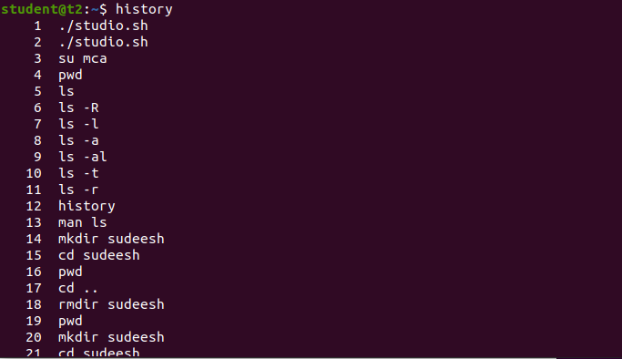

1. man ls : we can learn and understand about different command right from shell.

**$ man ls**

**Output:**

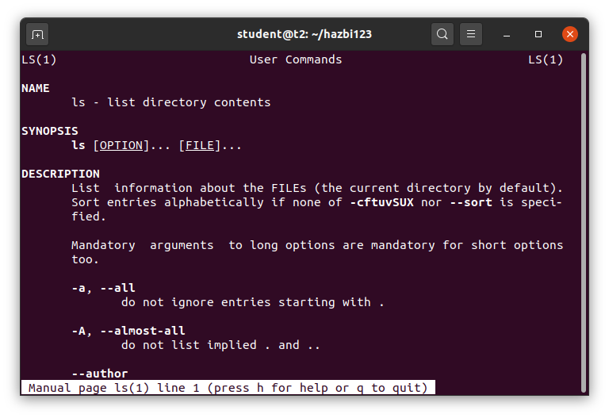

1. cat commands;
   1. cat >filename : to create a new file.

**$ cat >file1**

**Output:**



* 1. cat filename : to display the content of a file.

**$ cat file1**

**Output:**



* 1. cat >>filename : to add content in a file.

**$ cat >>file1**

**Output:**

* 1. cat -n filename : displays line numbers in front of each line in a file.

**$ cat -n file1**

**Output:**



* 1. cat -b : removes numbering of the empty lines.

**$ cat -b filename**

**

**Result:** The program was executed successfully and result was obtained.